**HM2 A word count example in Hadoop using Java**

Liang(Charles) Dai

1. Run the image in VMware fusion

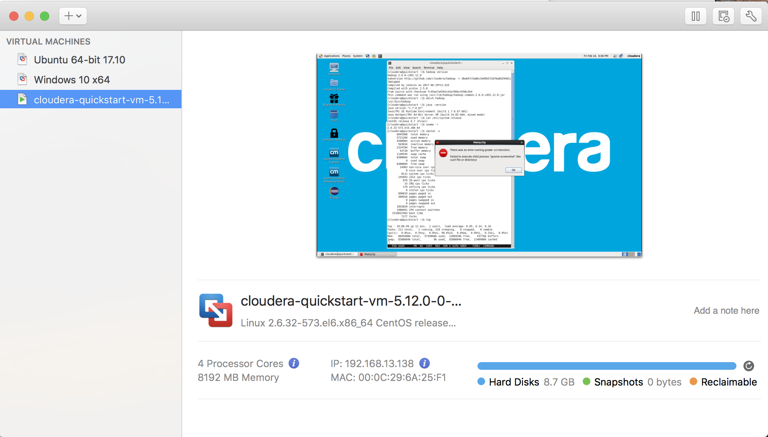

1. Open the CLI, use the following command
2. hadoop version
3. which Hadoop
4. java –version
5. cat /etc/system-release
6. uname –r
7. vmstat –s
8. top

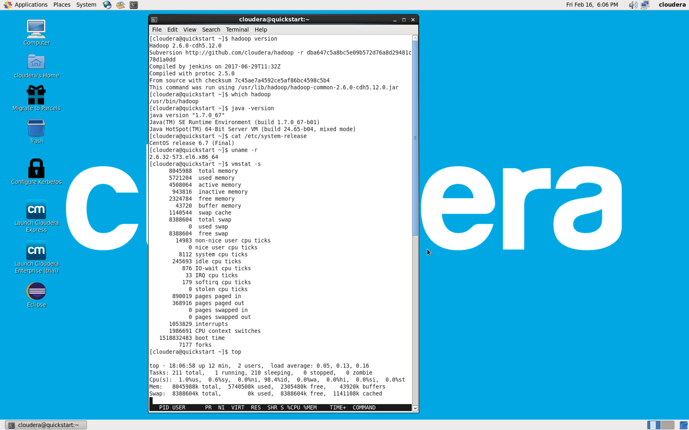

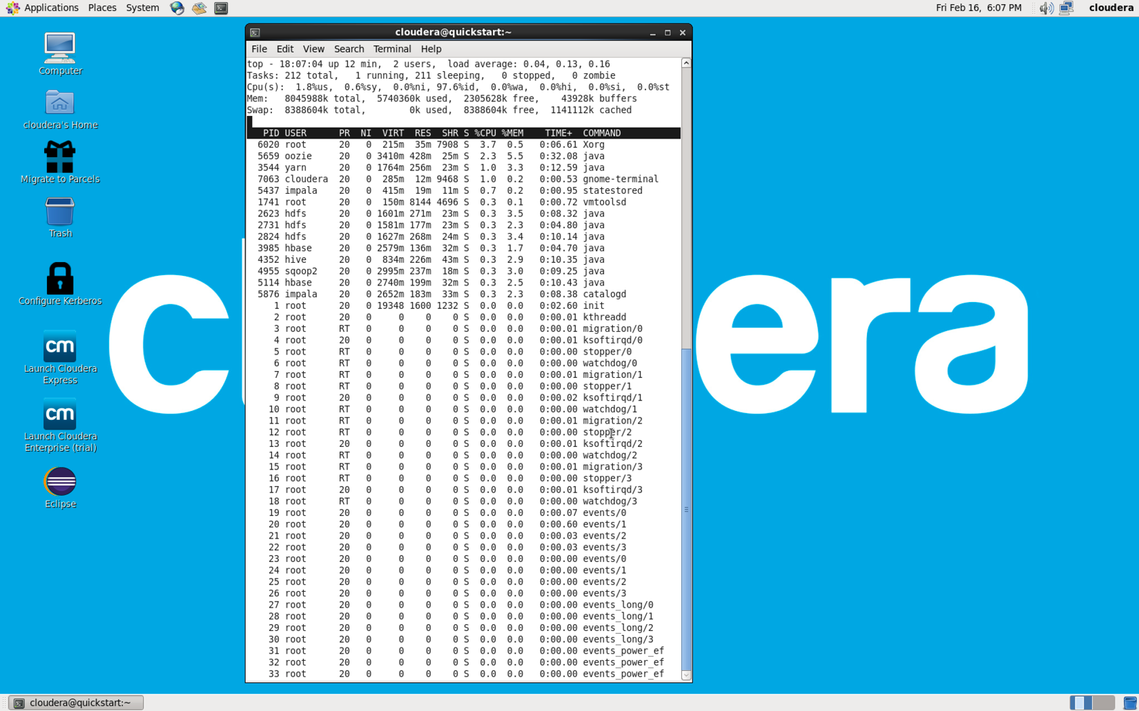

1. Install htop
2. wget [http://pkgs.repoforge.org/rpmforge-release/rpmforge-release-0.5.3-1.el6.rf. x86_64.rpm](http://pkgs.repoforge.org/rpmforge-release/rpmforge-release-0.5.3-1.el6.rf.%20x86_64.rpm)

This website is going down couldn’t connected. Use the mirror instead

http://repository.it4i.cz/mirrors/repoforge/redhat/el6/en/x86_64/rpmforge/RPMS/rpmforge-release-0.5.3-1.el6.rf.x86_64.rpm

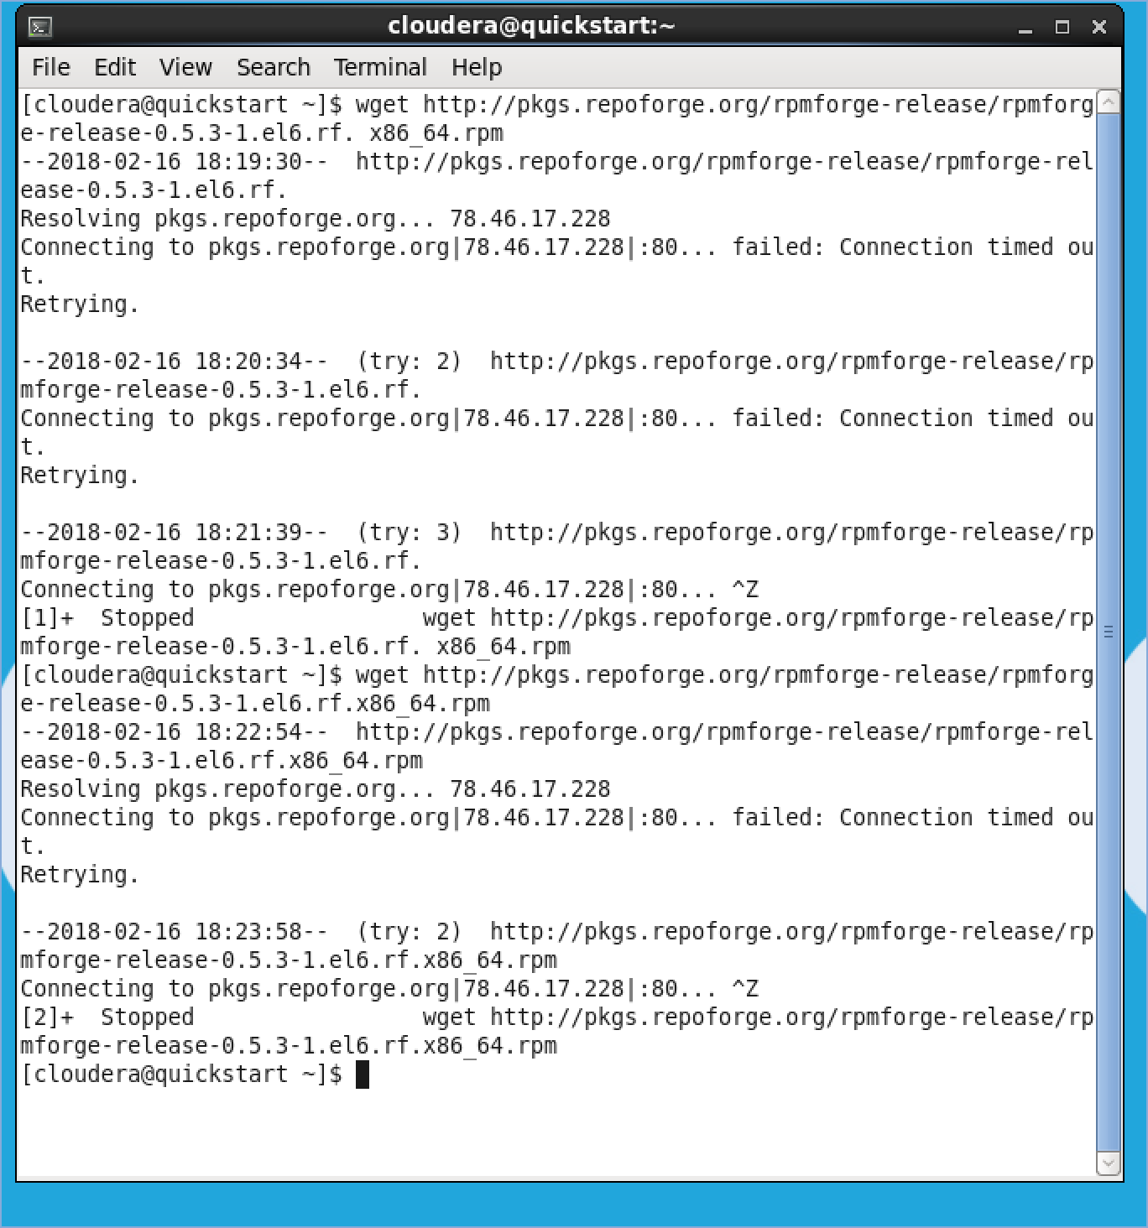

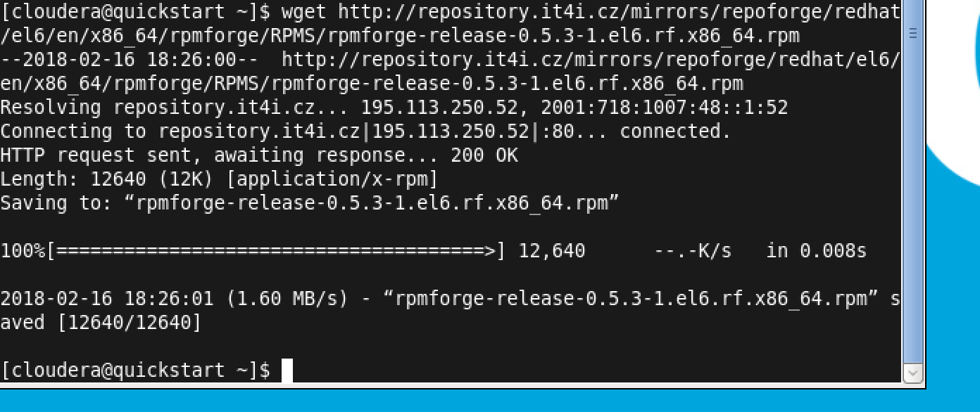

1. rpm -ihv rpmforge-release-0.5.3-1.el6.rf.x86_64.rpm

need to run as administrator, otherwise you will get an error as permission denied.

[sudo rpm -ihv rpmforge-release-0.5.3-1.el6.rf.x86_64.rpm]

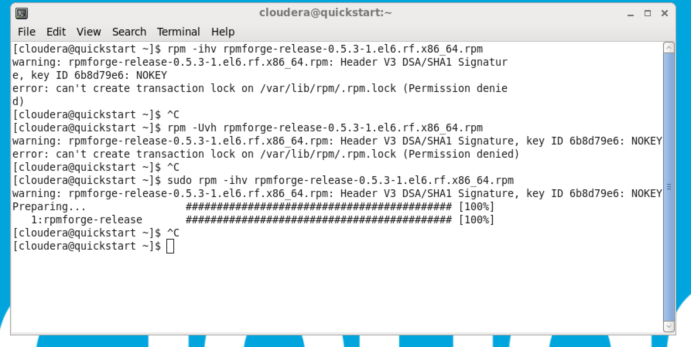

1. yum install htop

[sudo yum install htop]

